**Saturday May 4th, 2019**

7:43 — Time for a quick 15 minute pomodoro session to start the day.

7:47 — I’m back to working on the map challenge. I’ve done the basic set-up of the React app and now I’m going to try to implement Map again for the next 10 minutes.

7:51 — Unexpected interruption. I’ll get back to this in the afternoon after finishing some other unfortunately necessary projects.

14:46 — I’m back. Let’s get some work done.

15:02 — Random observation: As far as in what order they will be displayed, it doesn’t matter which order you assign values to your props in React. What matters more is the order they were listed in your original component.

15:05 — I’d imagine that by convention, however, it makes more sense to assign props in the value in which they were ordered in the original component — no need to unnecessarily complicate things.

17:05 — I learned a cool HTML tag today. <hr /> can be used to mark a horizontal gap between HTML elements. Here’s what it looks like in action: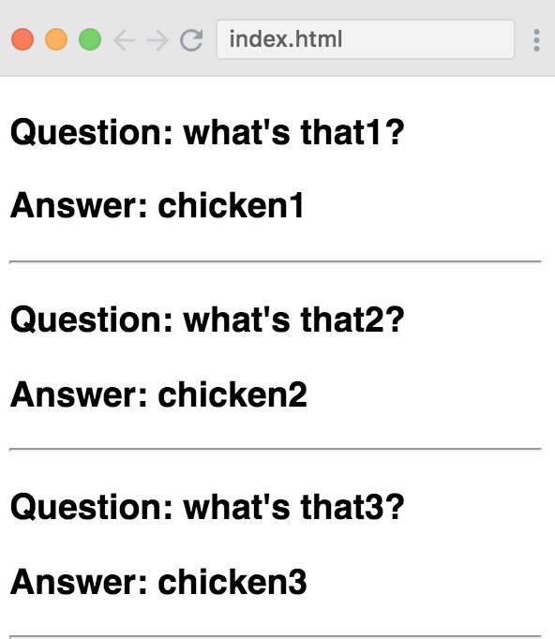

15:25 — I’m so confused. I have a decent understanding of how to use .map ( ) in JavaScript but the annoyances with trying to implement it in React are seemingly endless.

15:44 — I’m getting closer, but I still have a ways to go.

const productComponents = productsData.map(item => <Product product={item}/>)

18:42 — I’m back, and I have a good feeling that during this session I’ll finally finish the .map ( ) challenge.

18:57 — Small difference in our code. His code in his demonstration:

<h2>{props.product.name}</h2>

<p>{props.product.price.toLocaleString("en-US", { style: "currency", currency: "USD" })} - {props.product.description}</p>

My code:

<div>

Name: {Product.name}

Price: {Product.price}

<hr/>

</div>

)

}

I’d also tried using different variations of props.name and such but all of my attempts where unsuccessful.

19:07 — This error will be the end of me lol.

*Warning: React.createElement: type is invalid -- expected a string (for built-in components) or a class/function (for composite components) but got: array. Check the render method of `App`. in App*

19:13 — Oh. My. God. It looks like the errors the entire time were the result of a suuuuuper small syntax error. I tried to return my JavaScript const variables as a JSX element. For example: <ProductComponents />. This, however, is neither a valid JSX component nor a standard HTML tag. What I should have instead tried returning this entire time is my variable in plain old JavaScript as so: {ProductComponents}

19:16 — I think that when I come back for another coding session tonight that I’ll go back to FreeCodeCamp’s exercises for a session or two. This will help me solidify the fundamentals before I continue progressing in Bob Ziroll’s *Learn React for Free* course.

22:32 — Going to head to bed early tonight to catch up on sleep debt from staying up late night.

**Total time spent coding today: 1 hour 52 minutes**

**Total time spent coding in May 2019: 9 hours 15 minutes**